Robotics Process Automation Design and Development (UiPath) – BCG701 Lab
Experiment No: 2
Title: Develop automation in UiPath StudioX to demonstrate the following activities: if, Switch., Repeat Number of Times, Skip Current, Exit Loop.

Aim: To develop an automation in UiPath StudioX to demonstrate the following activities:
- If
- Switch
- Repeat Number of Times
- Skip Current
- Exit Loop

Theory:
- If: The If activity allows you to check for a condition and, based on the result, chooses which path the automation should follow. The automation can either follow the Then path or the Else path. The automation will follow the Then path in cases where the condition is true. Otherwise, the automation will follow the Else path. The If activity is also known as a decision activity, condition activity, or if-then-else activity.
- Switch: The Switch activity allows you to define multiple cases, and then based on an expression, it executes a single case. The If activity and Switch activity are conditional activities, that is, based on the expression results, they follow one of the defined paths. You can use an If activity when there are two choices, while a Switch activity is better suited for multiple choices.
- Repeat Number of Times: The Repeat Number of Times activity allows you to repeat one or more activities a specified number of times. Typically, this activity will be used in conjunction with the If, Skip Current, and Exit Loop activities.
- Skip Current: The Skip Current activity allows you to skip the current iteration in a repeating activity. This activity is useful when you are iterating through a list of items using a repeating activity. Based on certain conditions, you may only want to process some items while ignoring the rest; then, you can use the Skip Current activity to skip the current iteration.
- Exit Loop: The Exit Loop activity allows you to terminate the repeating activity. This activity is useful when you are iterating through a list of items using a repeating activity. Based on certain conditions, if you want to terminate the repeating activity, then you can use Exit Loop activity.

Conduction:
If activity:
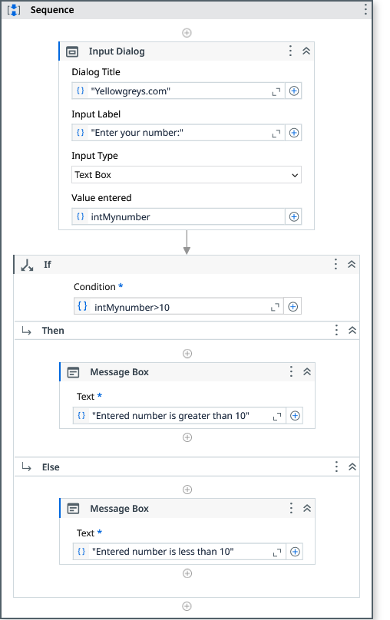

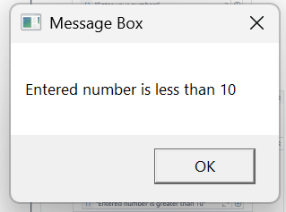
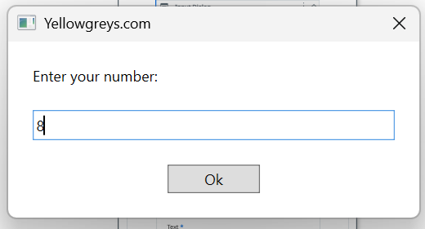
Output:

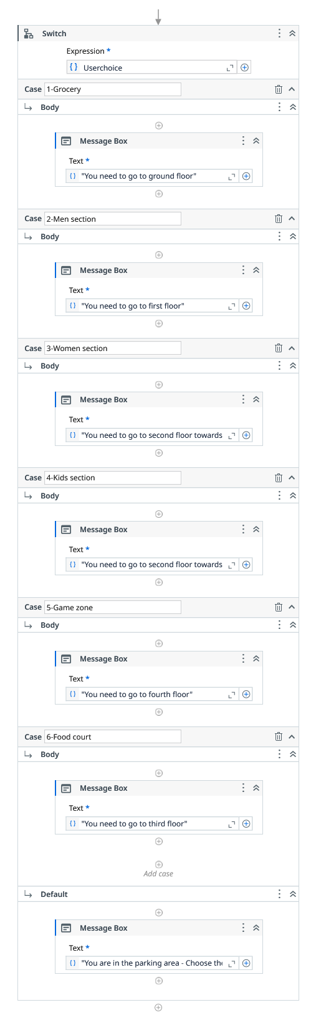
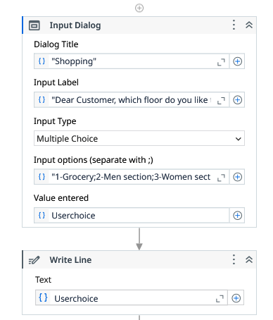
Switch activity:

Output:
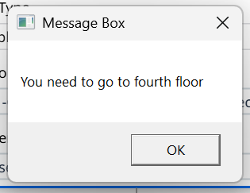
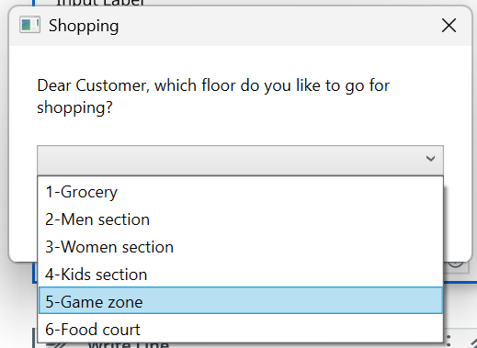

Repeat Number of Times activity:
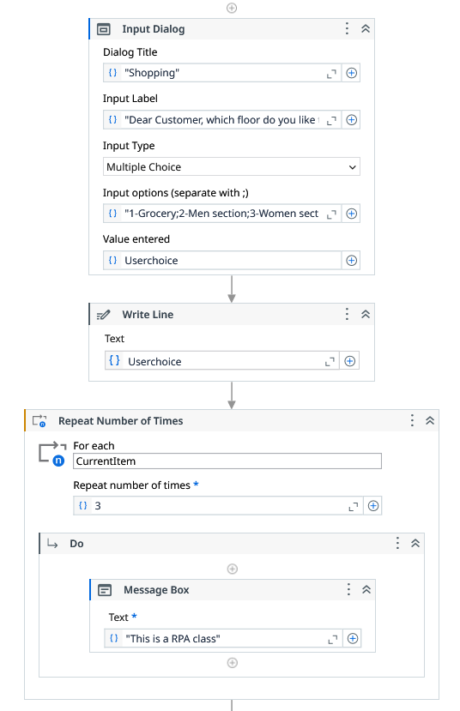

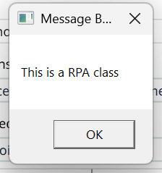
Output:

Skip Current activity (Continue):
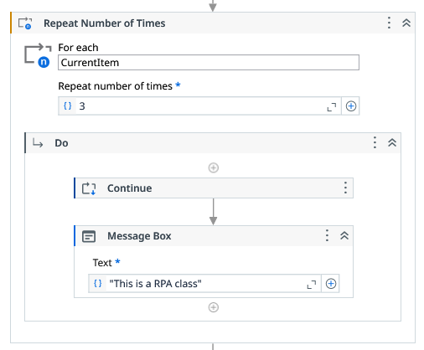

Exit Loop activity (Break):
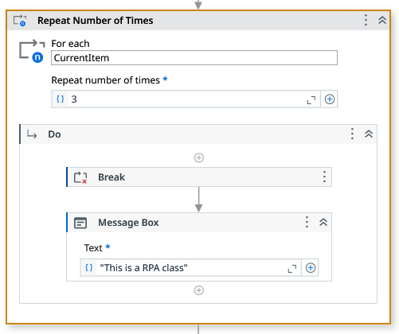

Output:
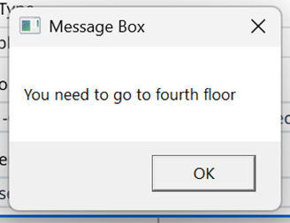

Observation and Results:
The following activities are demonstrated and executed using UiPath StudioX:
- If
- Switch
- Repeat Number of Times
- Skip Current
- Exit Loop

The output for the above-mentioned activities is verified.

Evaluation:
Evaluation Parameters | Maximum Marks | Obtained Marks
Conduction | 8
Record Writing | 4
Viva | 3
Total | 15

Signature of the Faculty incharge with date:

